1. Single Sign-on (SSO) from QHN Results to Colorado Specialty CareConnect (CSCC) eConsult
Without patient context

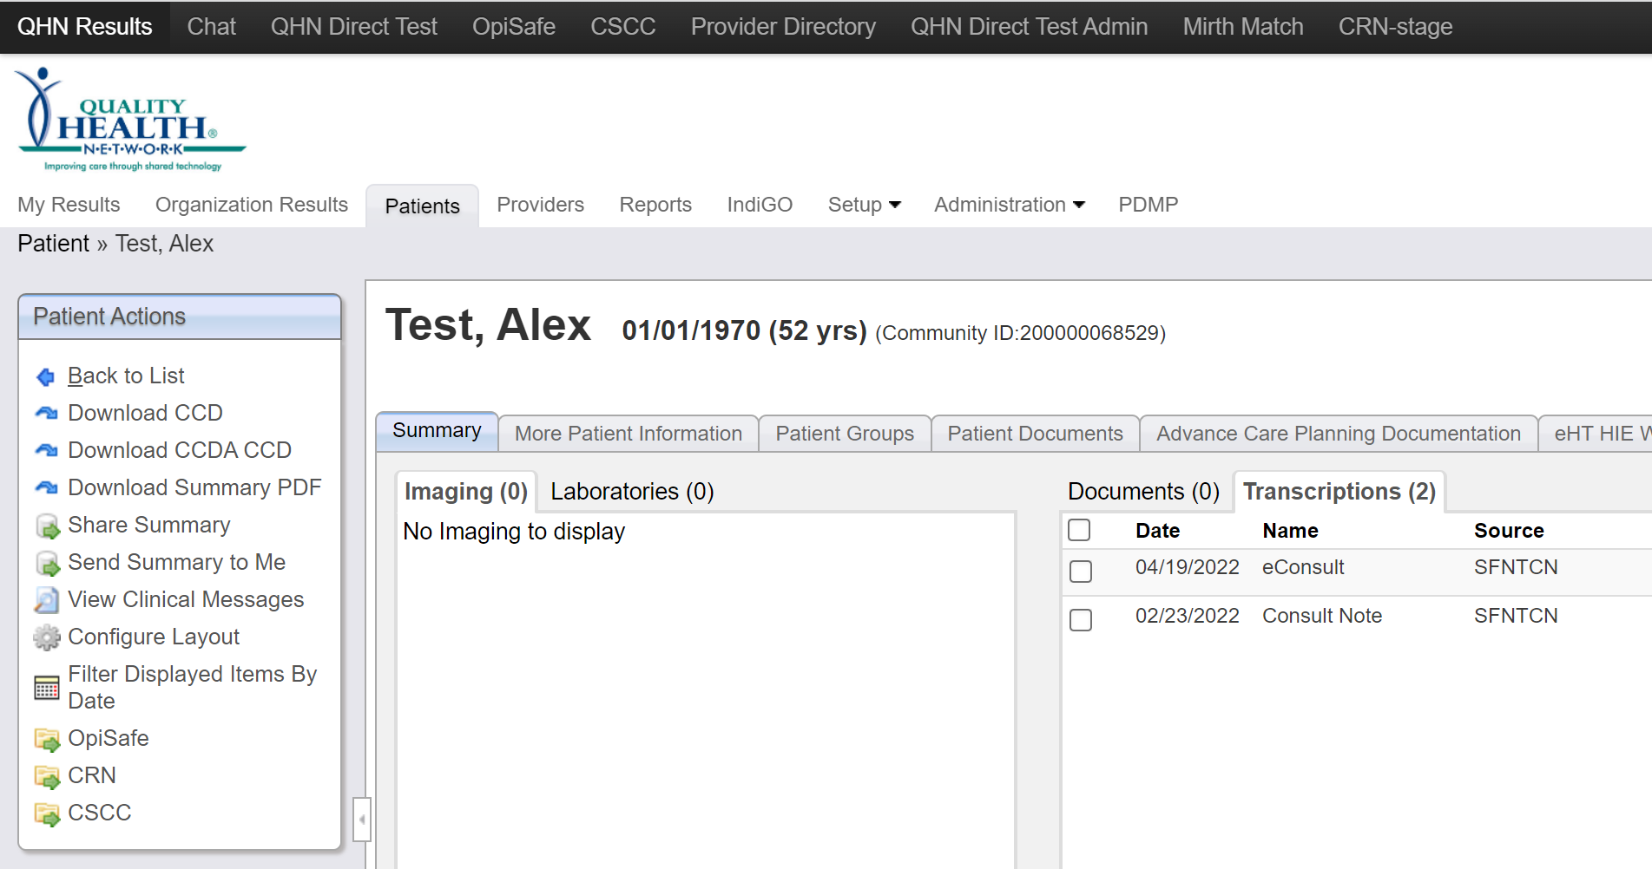
CSCC Landing Page
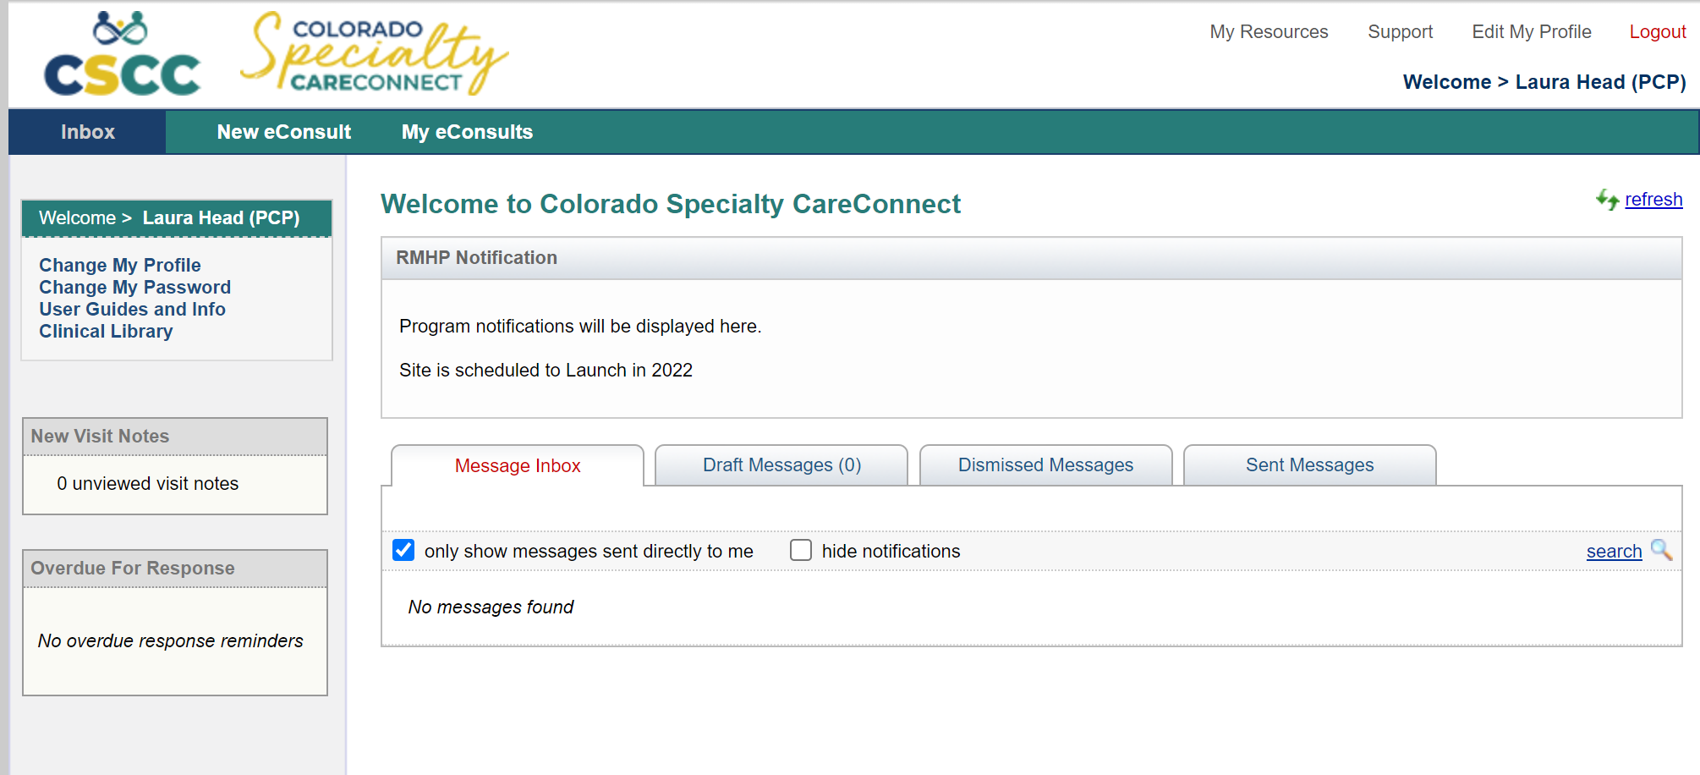
With patient context
NOTE: if the patient is not eligible for an eConsult you will get the following message.
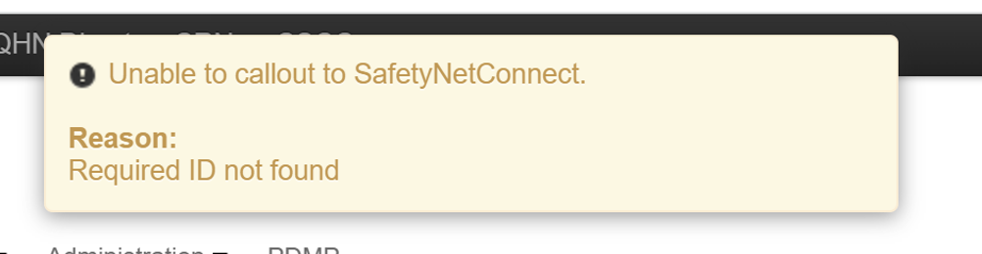

CSCC Landing Page
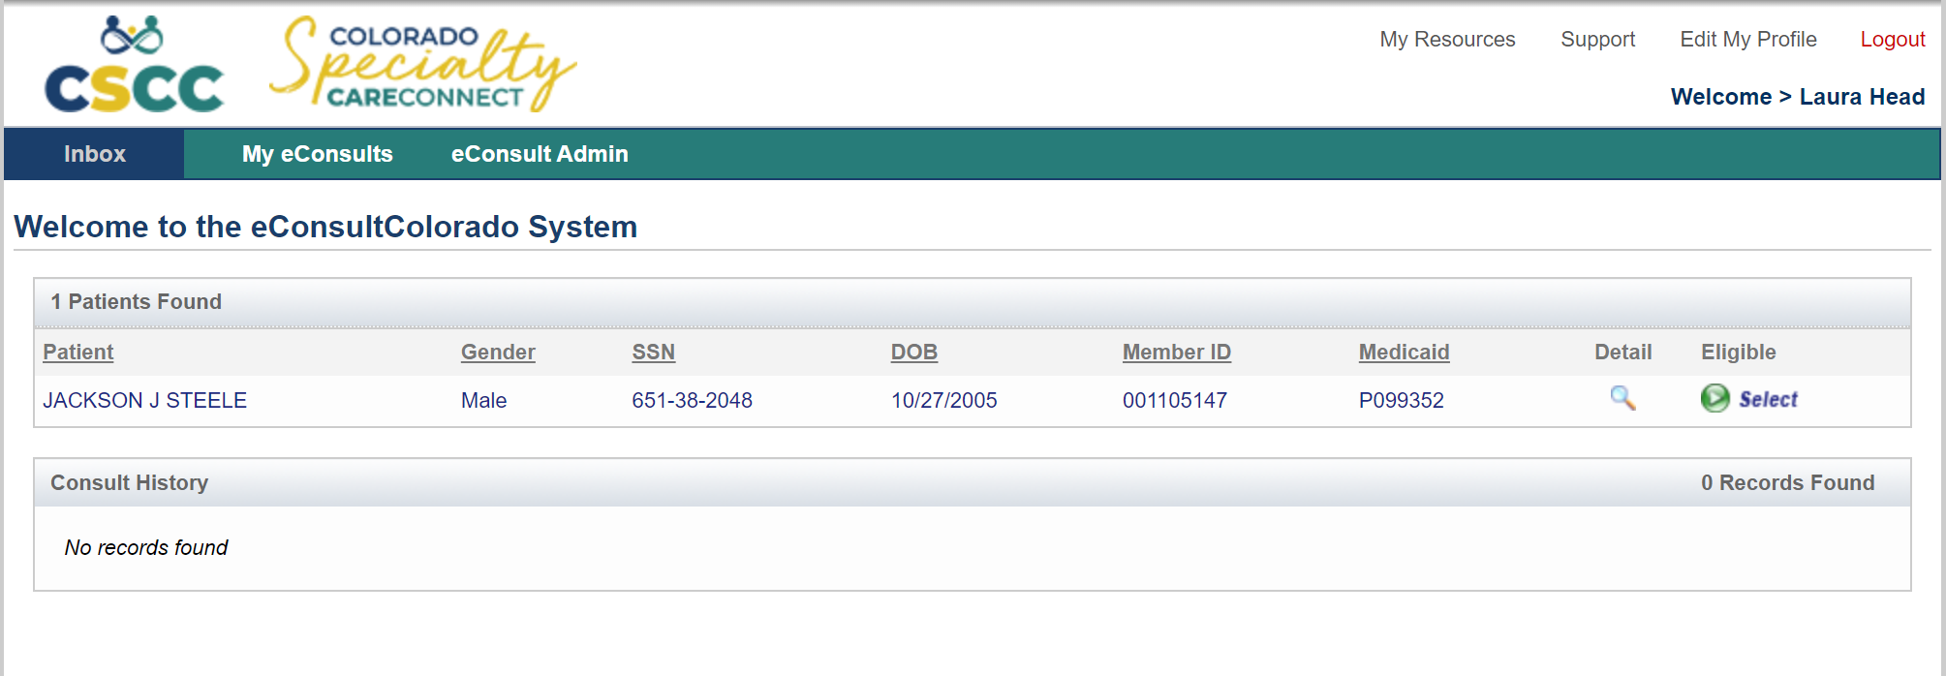
1/1/1970
Alex Test

Logout and close browser window when leaving CSCC

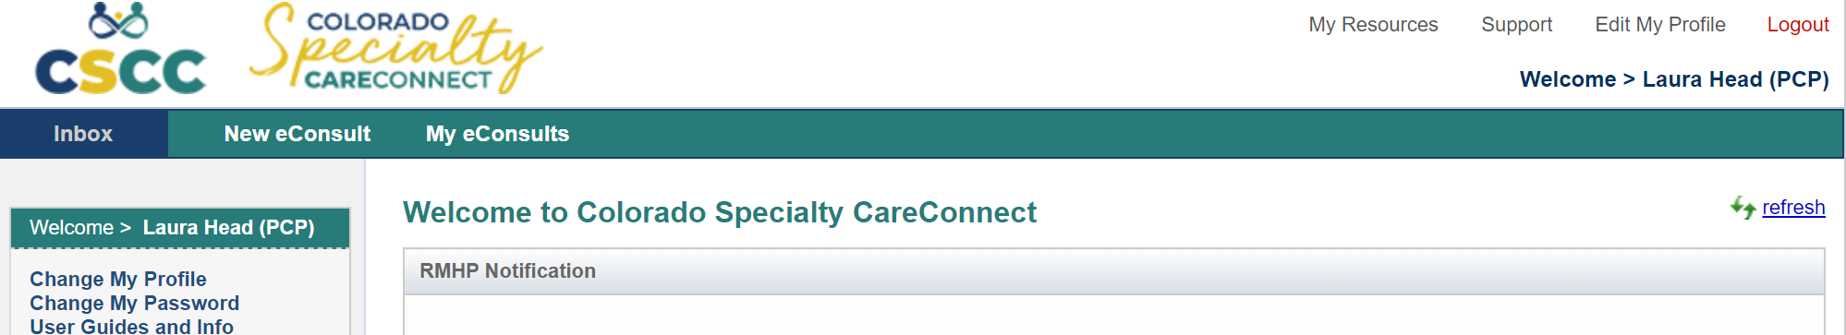

2. Save this website as a favorite in your browser:
https://econsultcolorado.com/mm/main/apps/index.mpl

3. Add this website to your favorites on your smartphone browser (safari or google)
https://econsultcolorado.com/mm/main/apps/index.mpl

